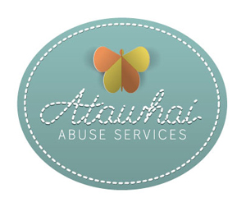

Atawhai Sexual Abuse Service

For all victims aged 15 years and above of sexual violence recent or historic we offer

* Support
* Information
* Medical care
* Psychological care
* ACC advice and referral
* Testing and treatment for infections
* 24 hour Forensic sample collection
* Co-ordination of services
* Advocacy through the legal system
* Help for victims to regain control of their lives and relationships

Free Service

Hour long appointments

No referral required

Appointments made by phoning 0800 ATAWHAI (0800 282 9424) and asking for an Atawhai appointment.

Everyone who has been abused is entitled to come and talk with us about the care that they need.

It is our goal to make sure they are given all the information they need to make the best choices about their care and recovery.

This might involve helping them to find a counselor, then following up to make sure that the counselor is appropriate and effective.

Providing short term supports for anxiety, grief, sleep difficulties.

Offering medical examinations to check for injuries or infections.

Discussing legal options and the justice system.

Assessing safety and risk.

The collection of forensic information when the circumstances of the event are not clear, just in case they are required. These remain the property of the victim until such time as they choose to release them to the police.

Follow up until the patient no longer requires our help.

Effective communication with all members of their health multidisciplinary team including their GP, Police, ACC.

Our aim is to enable people to live lives free of the consequences of sexual violence, empowering people to end all forms of abuse

Our goal is to provide patient centered holistic care in a safe and welcoming environment.